DJANGO UNCHAINED

By

Siddarth Naik

Sai Balaguru Ganess

V. Jahnavi Reddy

Swetha Vemparala

# INTRODUCTION:

The aim of this project is to traverse through a list of tables which are interlinked through a primary key and then print the columns required from the last table. Using the attributes of first table, which are not primary keys, we search for a table which has the non-key attributes of first table as the primary key of second table. Here, finding this new table is a task since we are also running a piece of code to find its location.

### SQLITE3:

SQLITE is a [relational database management system](https://en.wikipedia.org/wiki/Relational_database_management_system) (RDBMS) contained in a [C](https://en.wikipedia.org/wiki/C_(programming_language)) [library](https://en.wikipedia.org/wiki/Library_(computer_science)). In contrast to many other database management systems, SQLite is not a [client–server](https://en.wikipedia.org/wiki/Client%E2%80%93server) database engine. Rather, it is embedded into the end program.

SQLite is [ACID](https://en.wikipedia.org/wiki/ACID)-compliant and implements most of the [SQL](https://en.wikipedia.org/wiki/SQL) standard, generally following [PostgreSQL](https://en.wikipedia.org/wiki/PostgreSQL) syntax. However, SQLite uses a dynamically and weakly [typed](https://en.wikipedia.org/wiki/Data_type) SQL [syntax](https://en.wikipedia.org/wiki/Syntax) that does not guarantee the [domain integrity](https://en.wikipedia.org/wiki/Data_integrity#TYPES). This means that one can, for example, insert a string into a column defined as an integer. SQLite will attempt to convert data between formats where appropriate, the string "123" into an integer in this case, but does not guarantee such conversions, and will store the data as-is if such a conversion is not possible.

SQLite is a popular choice as [embedded database](https://en.wikipedia.org/wiki/Embedded_database) software for local/client storage in [application software](https://en.wikipedia.org/wiki/Application_software) such as [web browsers](https://en.wikipedia.org/wiki/Web_browser). It is arguably the most widely deployed [database engine](https://en.wikipedia.org/wiki/Database_engine), as it is used today by several widespread browsers, [operating systems](https://en.wikipedia.org/wiki/Operating_system), and [embedded systems](https://en.wikipedia.org/wiki/Embedded_system) (such as mobile phones), among others. SQLite has [bindings](https://en.wikipedia.org/wiki/Language_binding) to many programming languages.

## SOURCE CODE:

import pandas as pd

import sqlite3

Here we are importing pandas and SQLITE3 packages.

con = sqlite3.connect("chinook.db")

cur = con.cursor()

query = """ Select name from sqlite_master where type = "table" """

Here we are establishing the connection with the database and selecting the table names present in the database and also creating a cursor to get the data.

res = cur.execute(query)

list_tables = res.fetchall()

Here we are executing the query and fetching the data that is in the cursor and putting all the table names in “chinook.db” into “list_tables”

table_name_columns = {}

for t_name in list_tables:

q1 = 'SELECT * FROM {}'.format(str(t_name[0]))

cursor = con.execute(q1)

temp1 = []

for i in range(len(cursor.description)):

temp1.append(cursor.description[i][0])

table_name_columns[str(t_name[0])] = temp1

Here we are creating a dictionary “table_name_columns” and inserting the column names of each table into the dictionary with “Table Name” as Keys.

name_col = table_name_columns['playlists'][0]

for key in table_name_columns.keys():

if name_col in table_name_columns[key]:

new_table = key

We search for the table which has a column named “playlist_id” and it’s stored in the variable new_table. The table is “playlist_tracks”

q2 = "select * from {}".format(new_table)

cur2 = con.execute(q2)

playlist_track = cur2.fetchall()

Here we are fetching the track_id from playlist_track table.

id = [1,3,5,8]

track_id = {}

for j in id:

counter = 0

temp = []

for i in range(len(playlist_track)):

if playlist_track[i][0] == j:

if(counter!=10):

counter+=1

temp.append(playlist_track[i][1])

else:

break

track_id[j] = temp

We have created list named “ID” and hard-coded the values as [1,3,5,8]. We fetch the respective “track_id” for each Playlist_id and store it in a dictionary – “track_id”

name_col1 = table_name_columns['playlist_track'][1]

for key in table_name_columns.keys():

if name_col1 in table_name_columns[key] and key != 'playlist_track':

new_table1 = key

We search for another table which contains the column – “Track_id” and store it in new_table1. The Table is: “Tracks”

q3 = "select * from {}".format(new_table1)

cur3 = con.execute(q3)

tracks = cur3.fetchall()

Here we are fetching all the values from table “Tracks”.

track_name = {}

for id in track_id.keys():

for i in track_id[id]:

for j in range(len(tracks)):

if tracks[j][0] == i:

track_name[i]=[tracks[j][1],tracks[j][2]]

Creating a dictionary that has track_id as the key and the list of track_name, album_id as the values.

.

name_col2 = table_name_columns['tracks'][2]

**for** key **in** table_name_columns.keys():

**if** name_col2 **in** table_name_columns[key] **and** key != 'tracks':

new_table2 = key

Here we search for another table that contains the column “album_id” and it’s stored in new_table2. The table is: “albums”

q4 = "select * from {}".format(new_table2)

cur4 = con.execute(q4)

albums = cur4.fetchall()

To fetch the contents of table albums

for id in track_name.keys():

for j in range(len(albums)):

if albums[j][0] == track_name[id][1]:

track_name[id].append(albums[j][1])

track_name[id].append(albums[j][2])

With album_id, we are fetching album_name and artist_id and it’s appended to the values of respective “track_id” in the dictionary “track_name”

name_col3 = table_name_columns['albums'][2]

for key in table_name_columns.keys():

if name_col3 in table_name_columns[key] and key != 'albums':

new_table3 = key

We traverse to the “artist” table using “Artist_id”. The table name is stored in new_table3.

q5 = "select * from {}".format(new_table3)

cur5 = con.execute(q5)

artists = cur5.fetchall()

We store the data in the list “artists”

for id in track_name.keys():

for j in range(len(artists)):

if artists[j][0] == track_name[id][3]:

track_name[id].append(artists[j][1])

Appending the artist_name from artists table to the values of track_name.

df = pd.DataFrame()

Creating a new dataframe

df['track_id'] = track_name.keys()

song_name = []

album_id = []

album_name = []

artist_id = []

artist_name = []

Creating lists for all columns

for key in track_name.keys():

song_name.append(track_name[key][0])

album_id.append(track_name[key][1])

album_name.append(track_name[key][2])

artist_id.append(track_name[key][3])

artist_name.append(track_name[key][4])

df['Song title'] = song_name

df['Album_id'] = album_id

df['Album Name'] = album_name

df['Artist ID'] = artist_id

df['Artist Name'] = artist_name

Appending the list for each column and concatenating it to the Data frame.

Inserting the lists into dataframes

play_id = []

Creating new list for the playlist_id.

x = list(df['track_id'])

for i in x:

if i in track_id[1]:

play_id.append(1)

elif i in track_id[3]:

play_id.append(3)

elif i in track_id[5]:

play_id.append(5)

elif i in track_id[8]:

play_id.append(8)

Inserting values into the list play_id in accordance with the Track_id.

df.insert(0,'Playlist ID',play_id)

Inserting the column “Playlist_id” to the Data Frame “df”

df

Viewing contents of data frame.

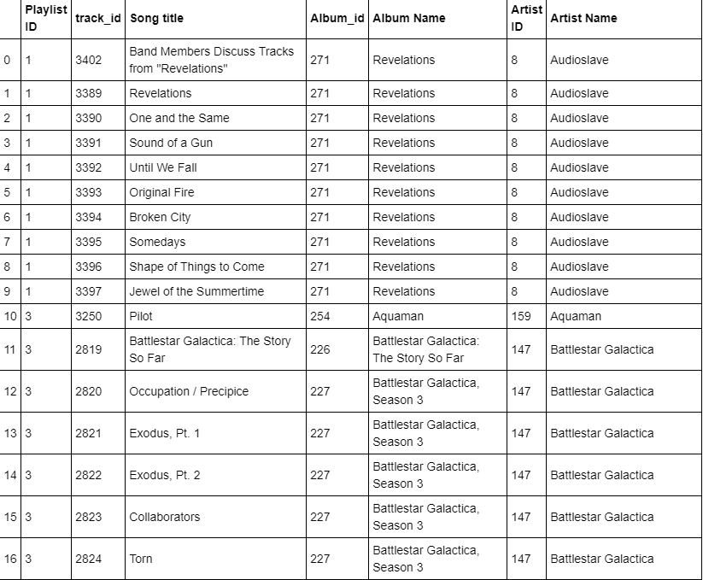

# Conclusion:

The given task has been completed and executed successfully.